
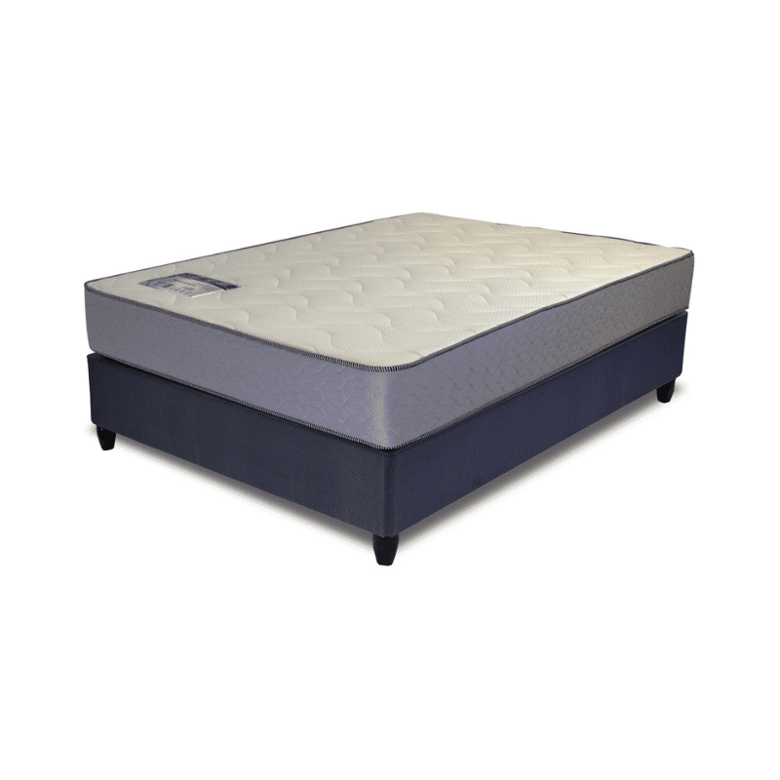

Model : Flex-O-Paedic Base Set
Supplier/Manufacturer : Rest Assured
Range : Matrix
Prices – Bed Set :
- Single Bed Set – R4079
- Three Quarter Bed Set – R4609
- Double Bed Set – R5309
- Queen Bed Set – R5859
- King Bed Set – R7419
Prices – Mattress Only :
- Single Mattress Only – R2819
- Three Quarter Mattress Only – R3179
- Double Mattress Only – R3769
- Queen Mattress Only – R4229
- King Mattress Only – R4899
Prices - Extra Length Bed Set :
- Single Extra Length Bed Set – R4409
- Three Quarter Extra Length Bed Set – R4979
- Double Extra Length Bed Set – R5739
- Queen Extra Length Bed Set – R6329
- King Extra Length Bed Set – R8019
Prices - Extra Length Mattress Only :
- Single Extra Length Mattress Only – R3049
- Three Quarter Extra Length Mattress Only – R3439
- Double Extra Length Mattress Only – R4069
- Queen Extra Length Mattress Only – R4569
- King Extra Length Mattress Only – R5289

*Please use this link for guideline for creating the page* - https://www.bedsonline.co.za/product/rest-assured-flex-o-peadic-medium-firm-queen/
Rest Assured Link - https://restassured.co.za/our-ranges/matrix/flex-o-peadic/

